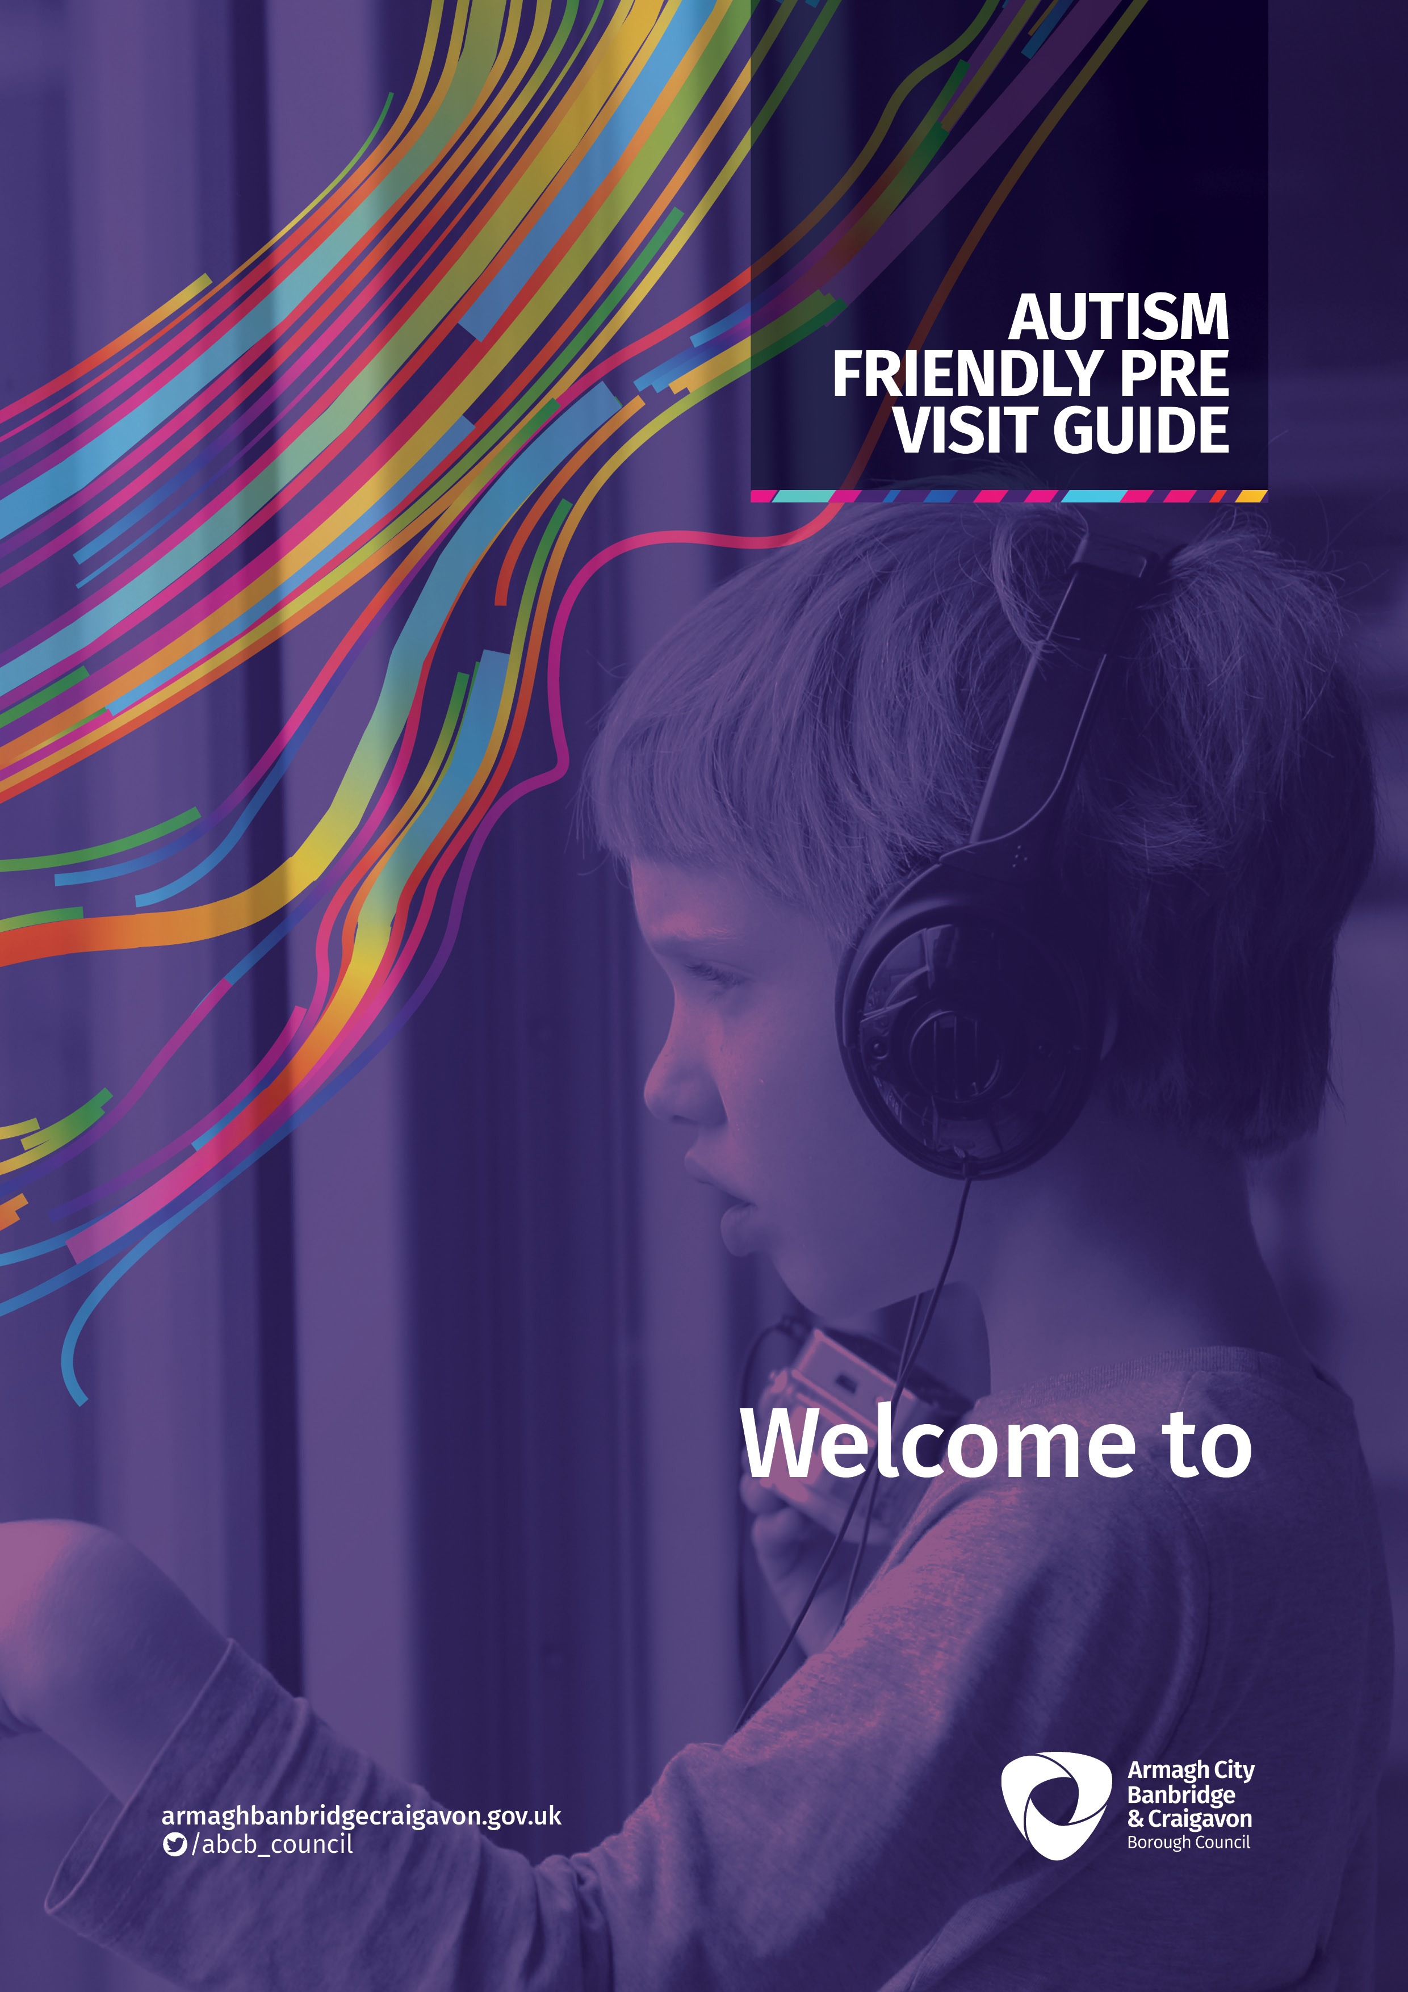
Tandragee Recreation Centre
Everyone feels different when trying something new.
There are new sounds, smells and you may not know what to expect.

Location of Venue: Tandragee Recreation Centre

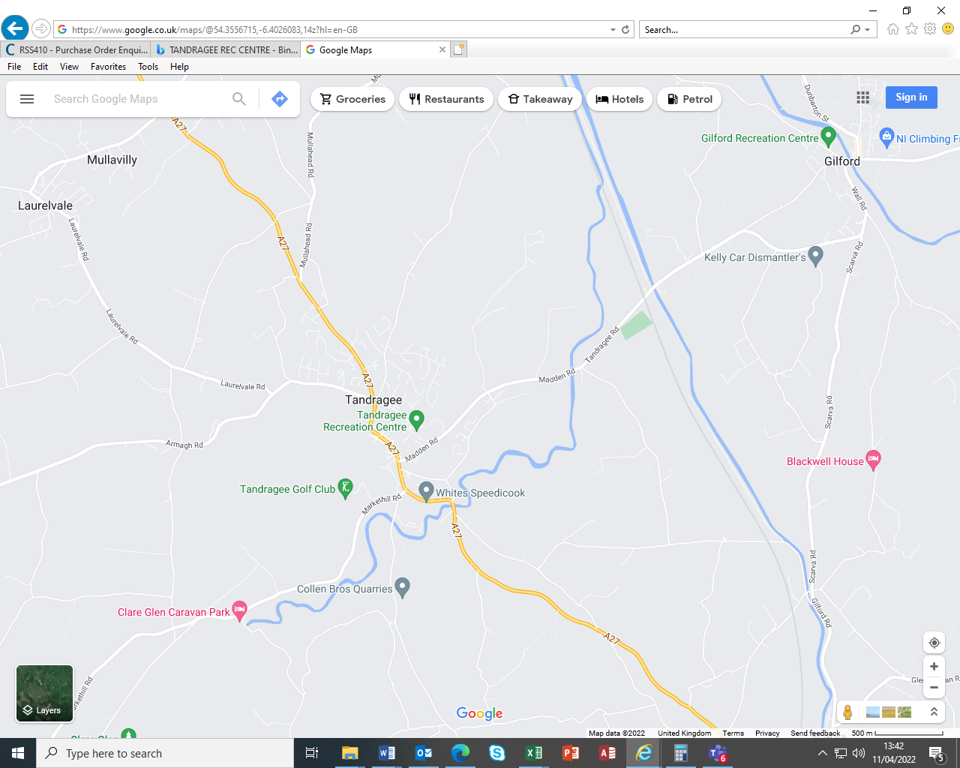

Tandragee Recreation can be accessed by bus / car / walking. Traffic will leave the A27 & A51 from Armagh or Portadown & Banbridge. Car Parking is available on site at the centre.

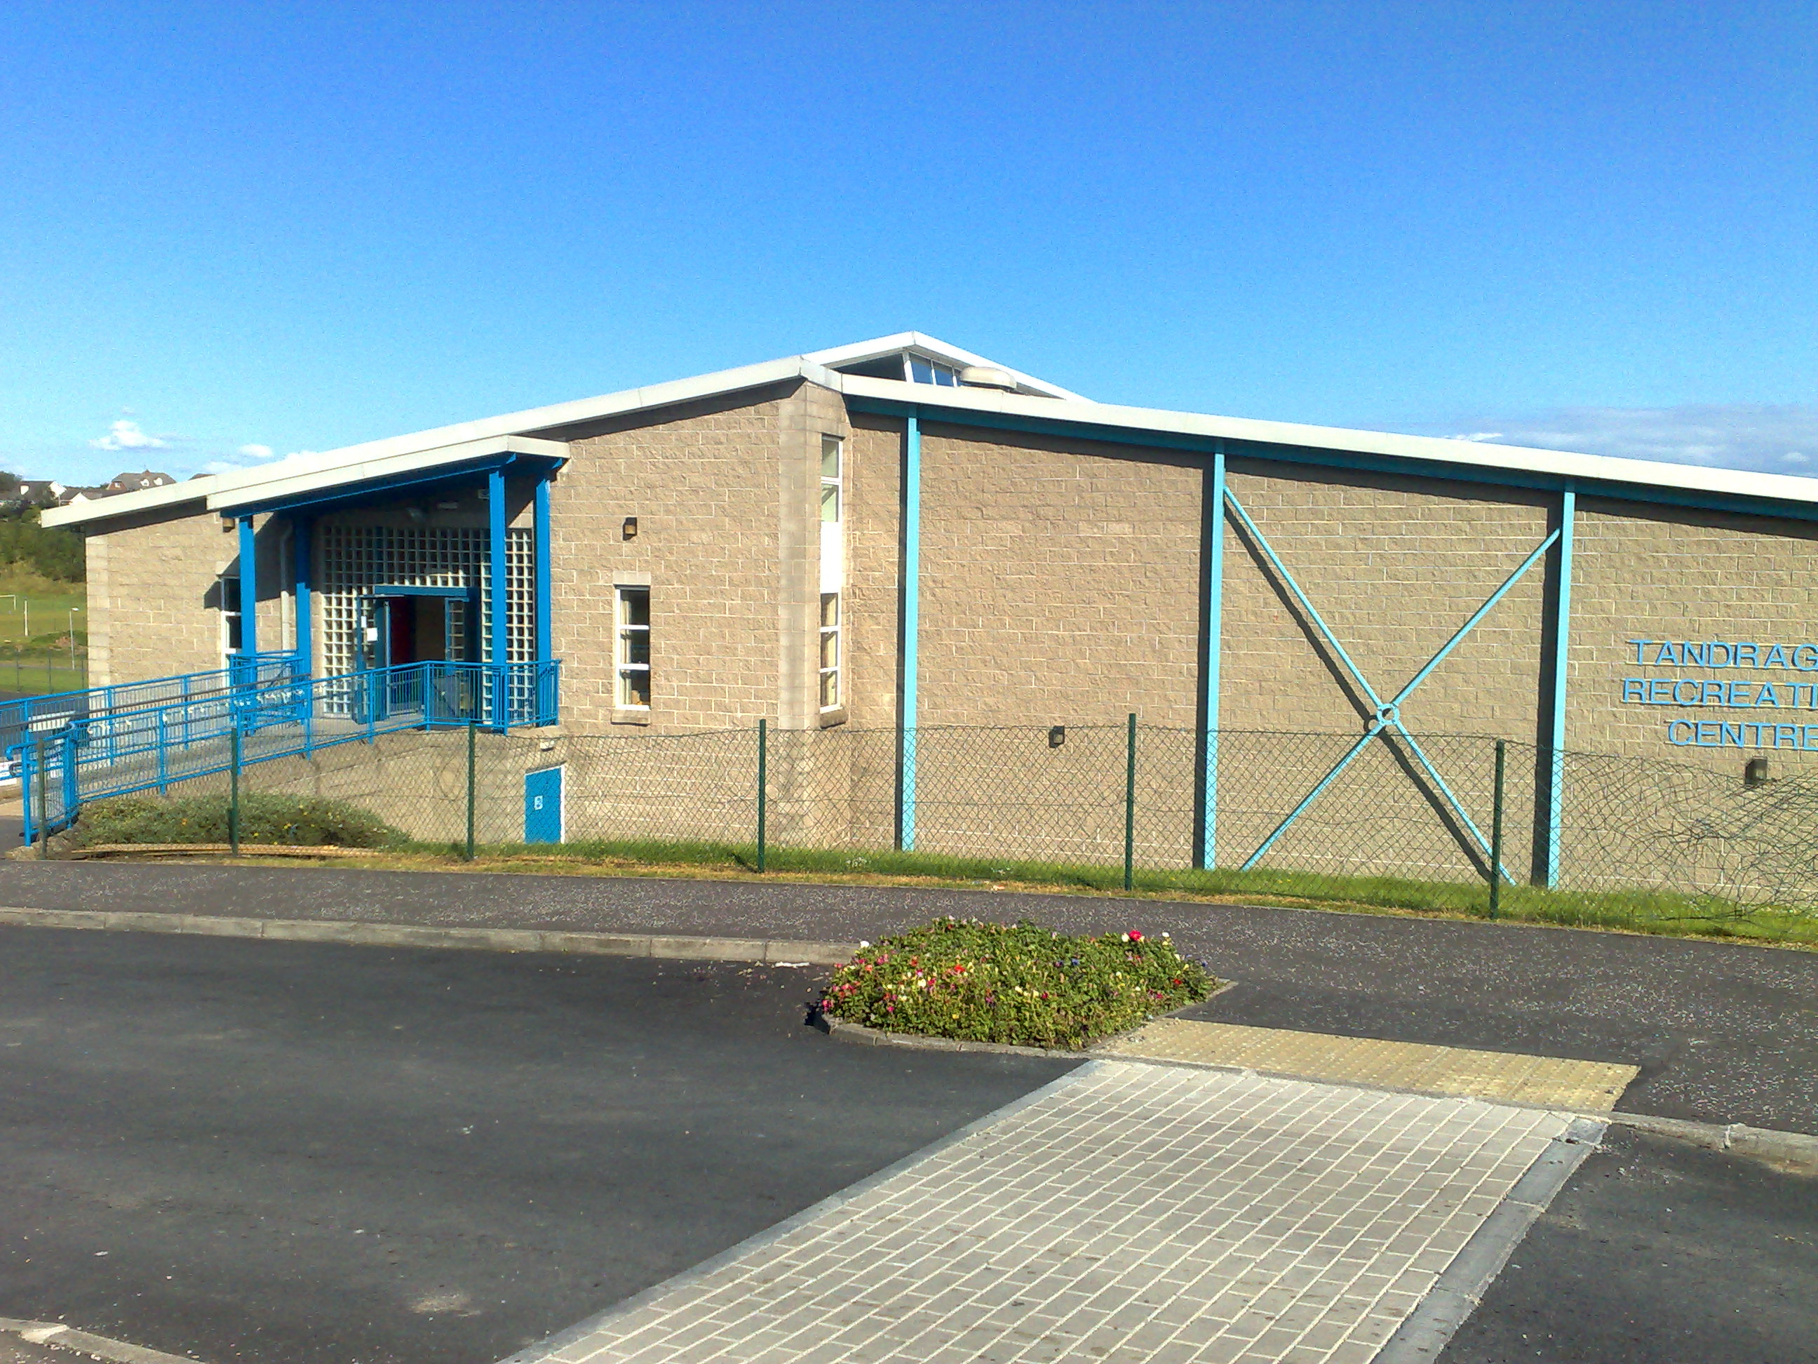

Car Parking is available at the front of the building. We have three separate car parks which can all be used by customers. We also provide disabled car parking spaces adjacent to the entrance door.
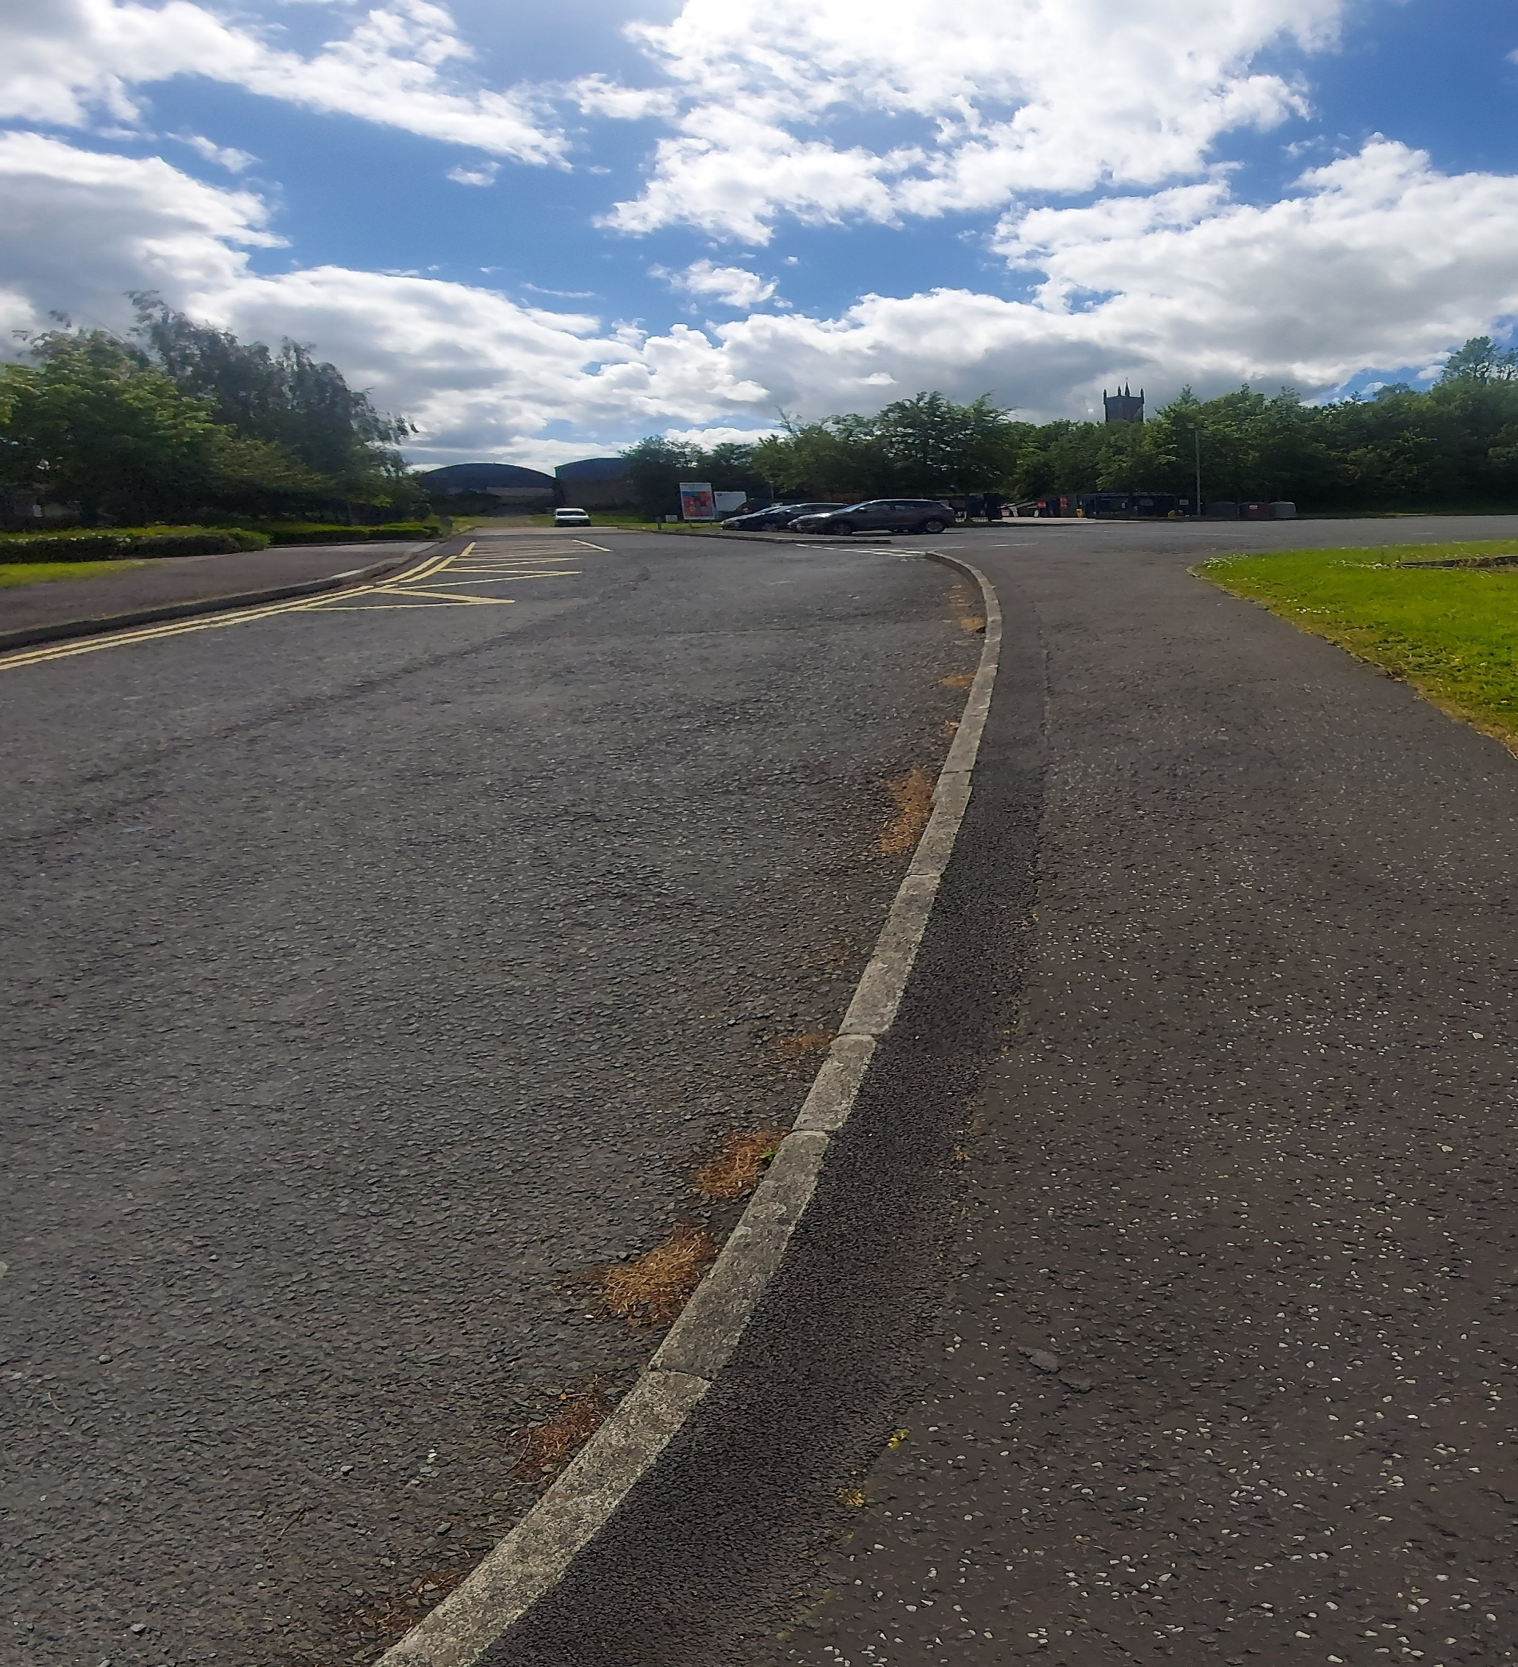

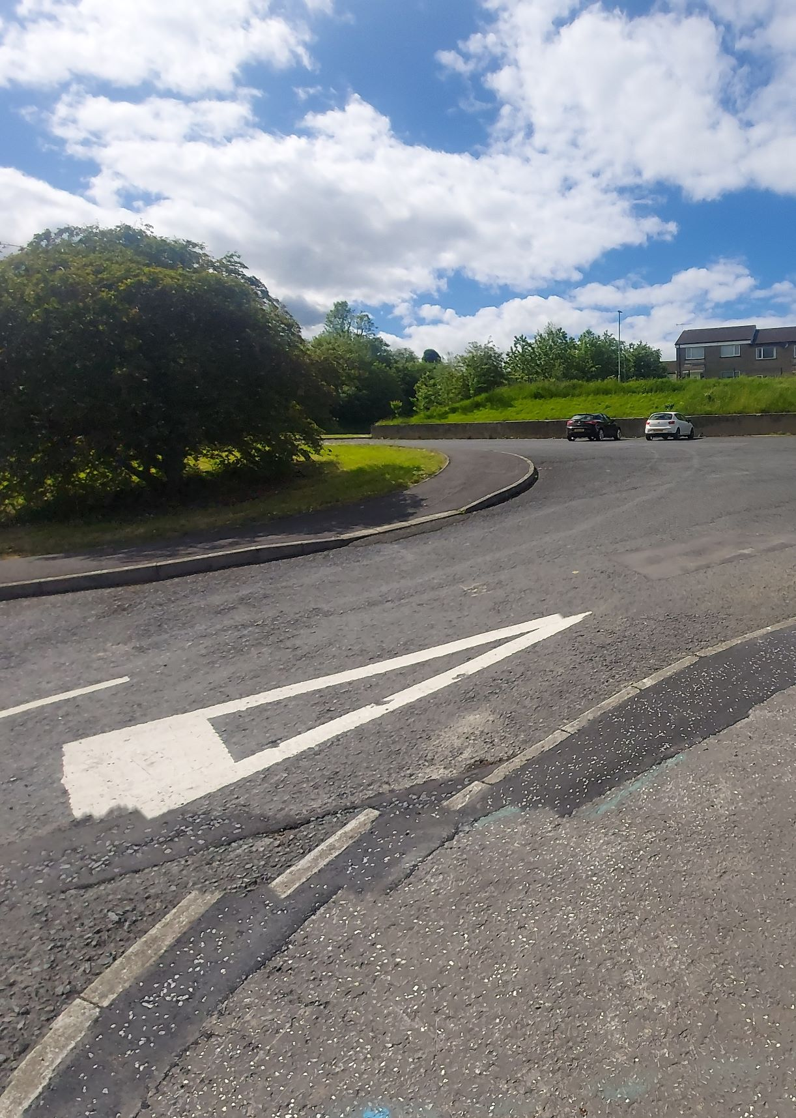
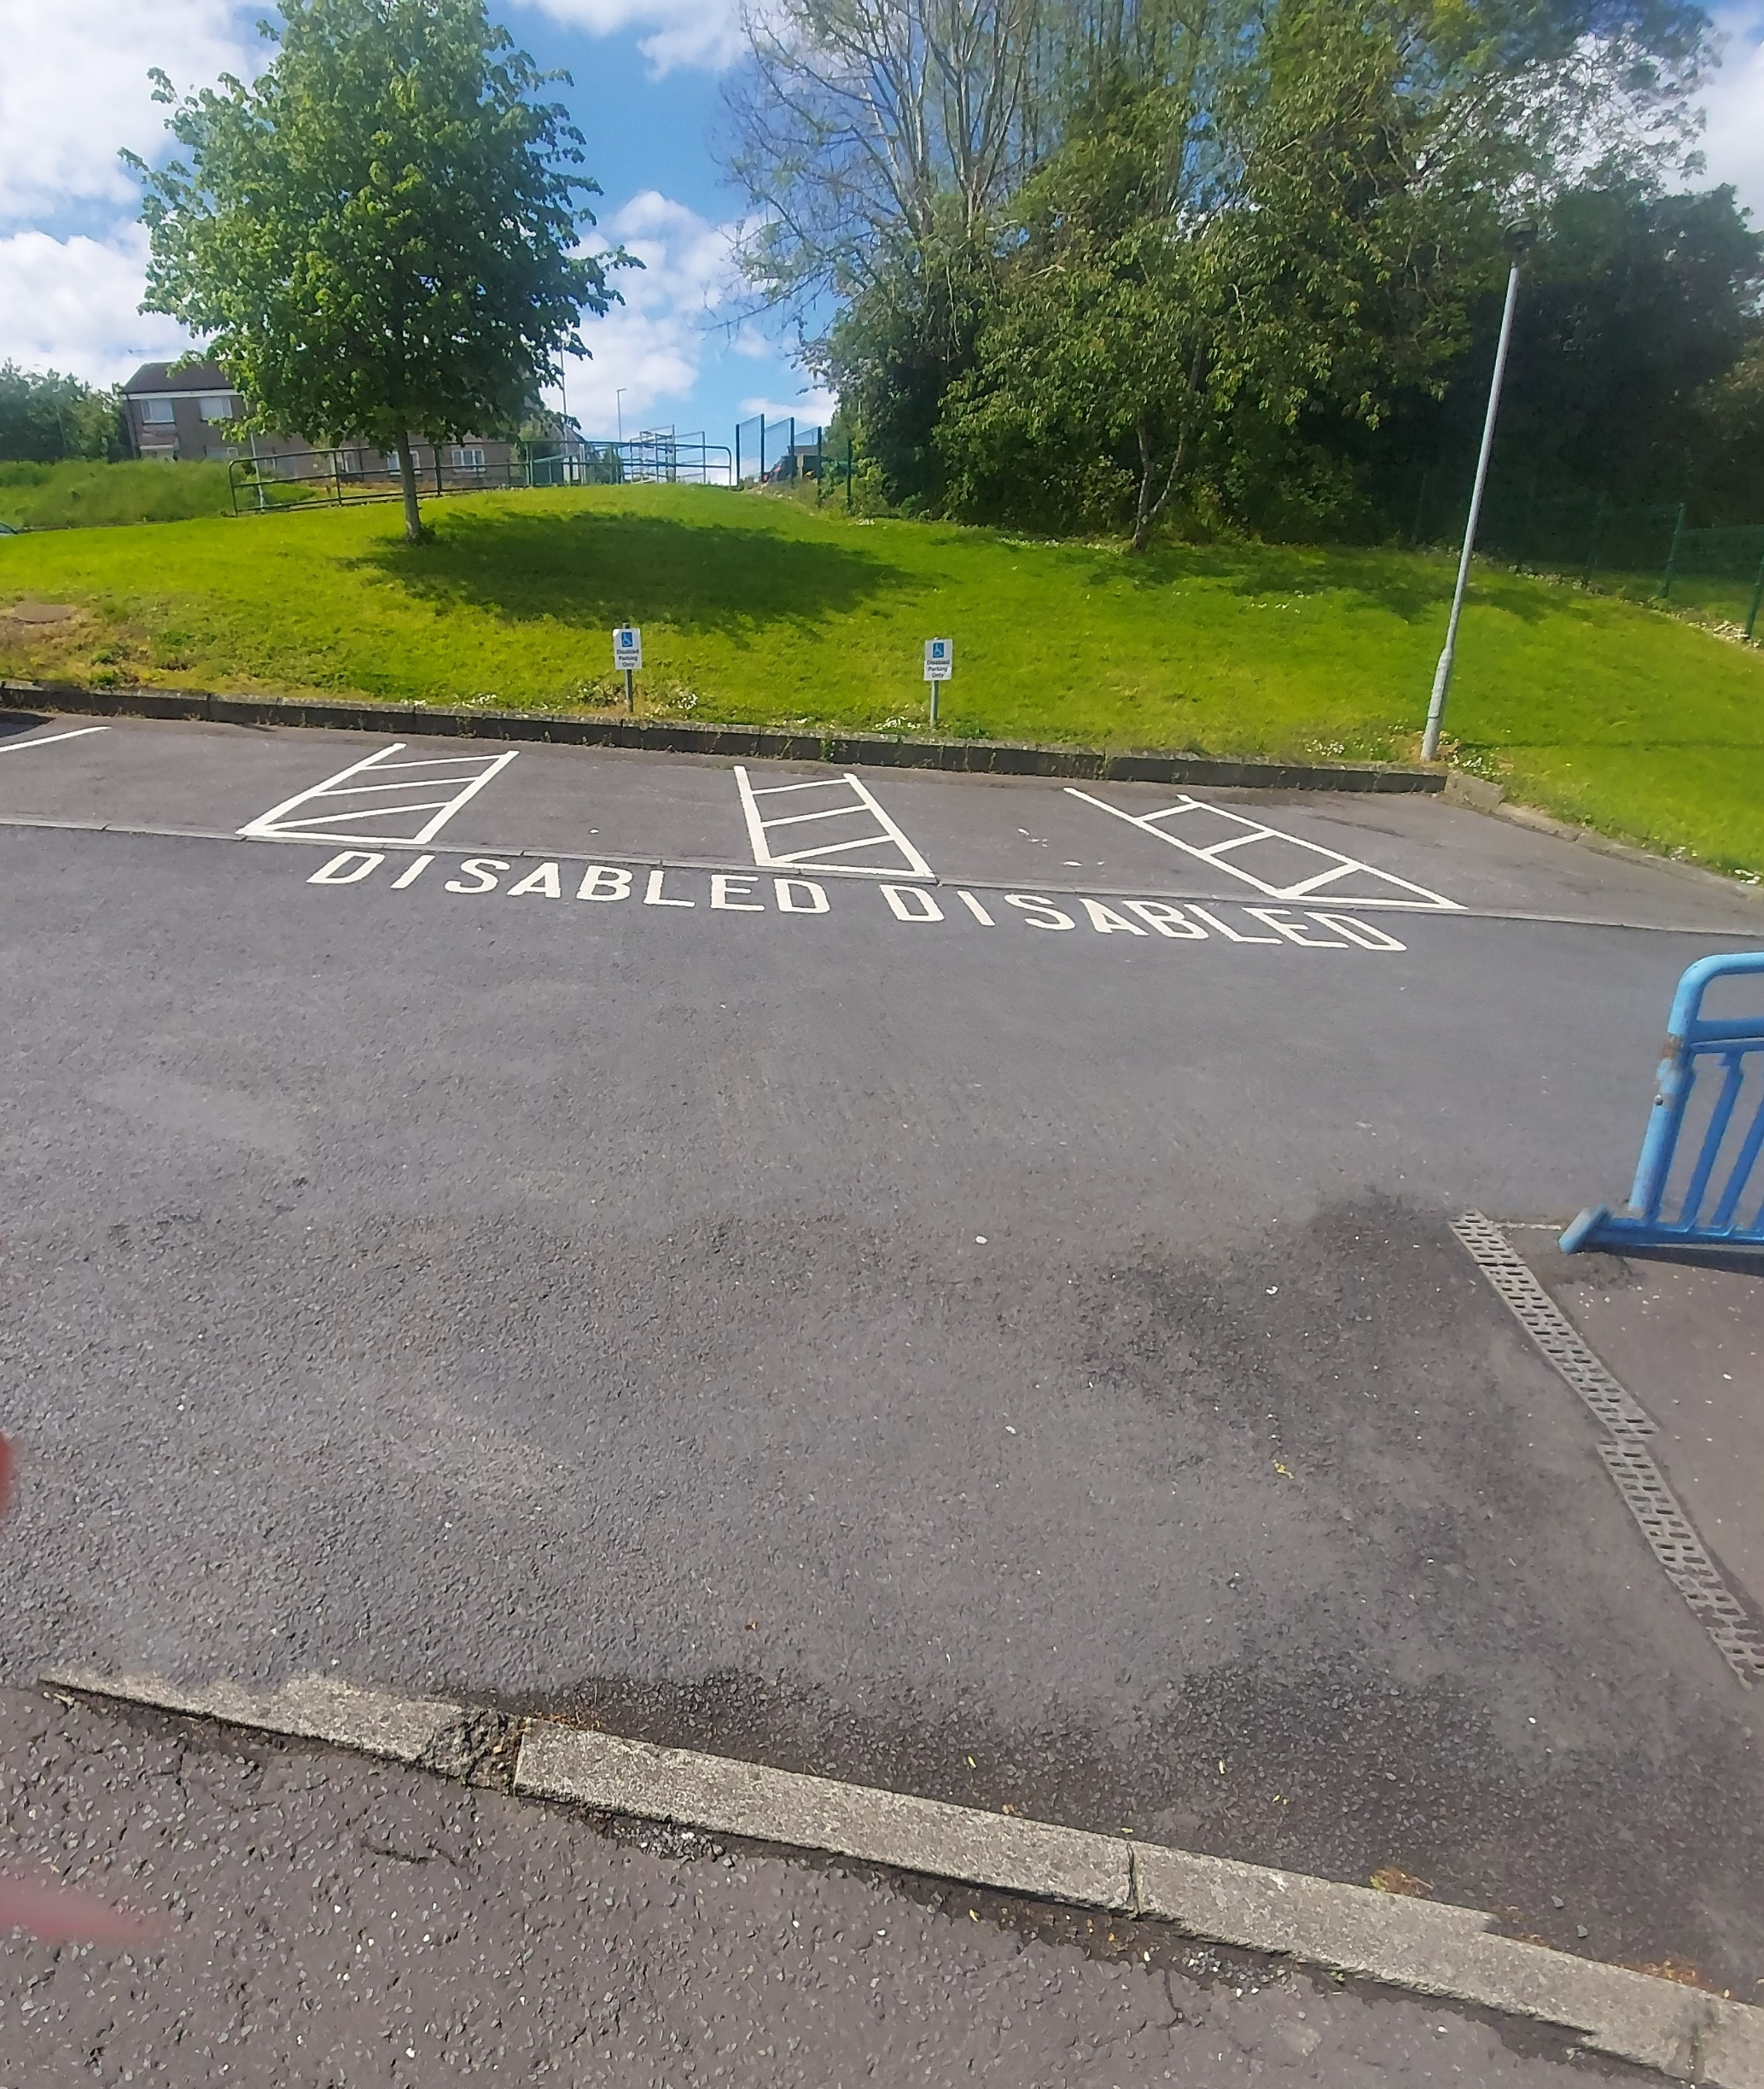

Welcome to Tandragee Recreation Centre - Reception Area

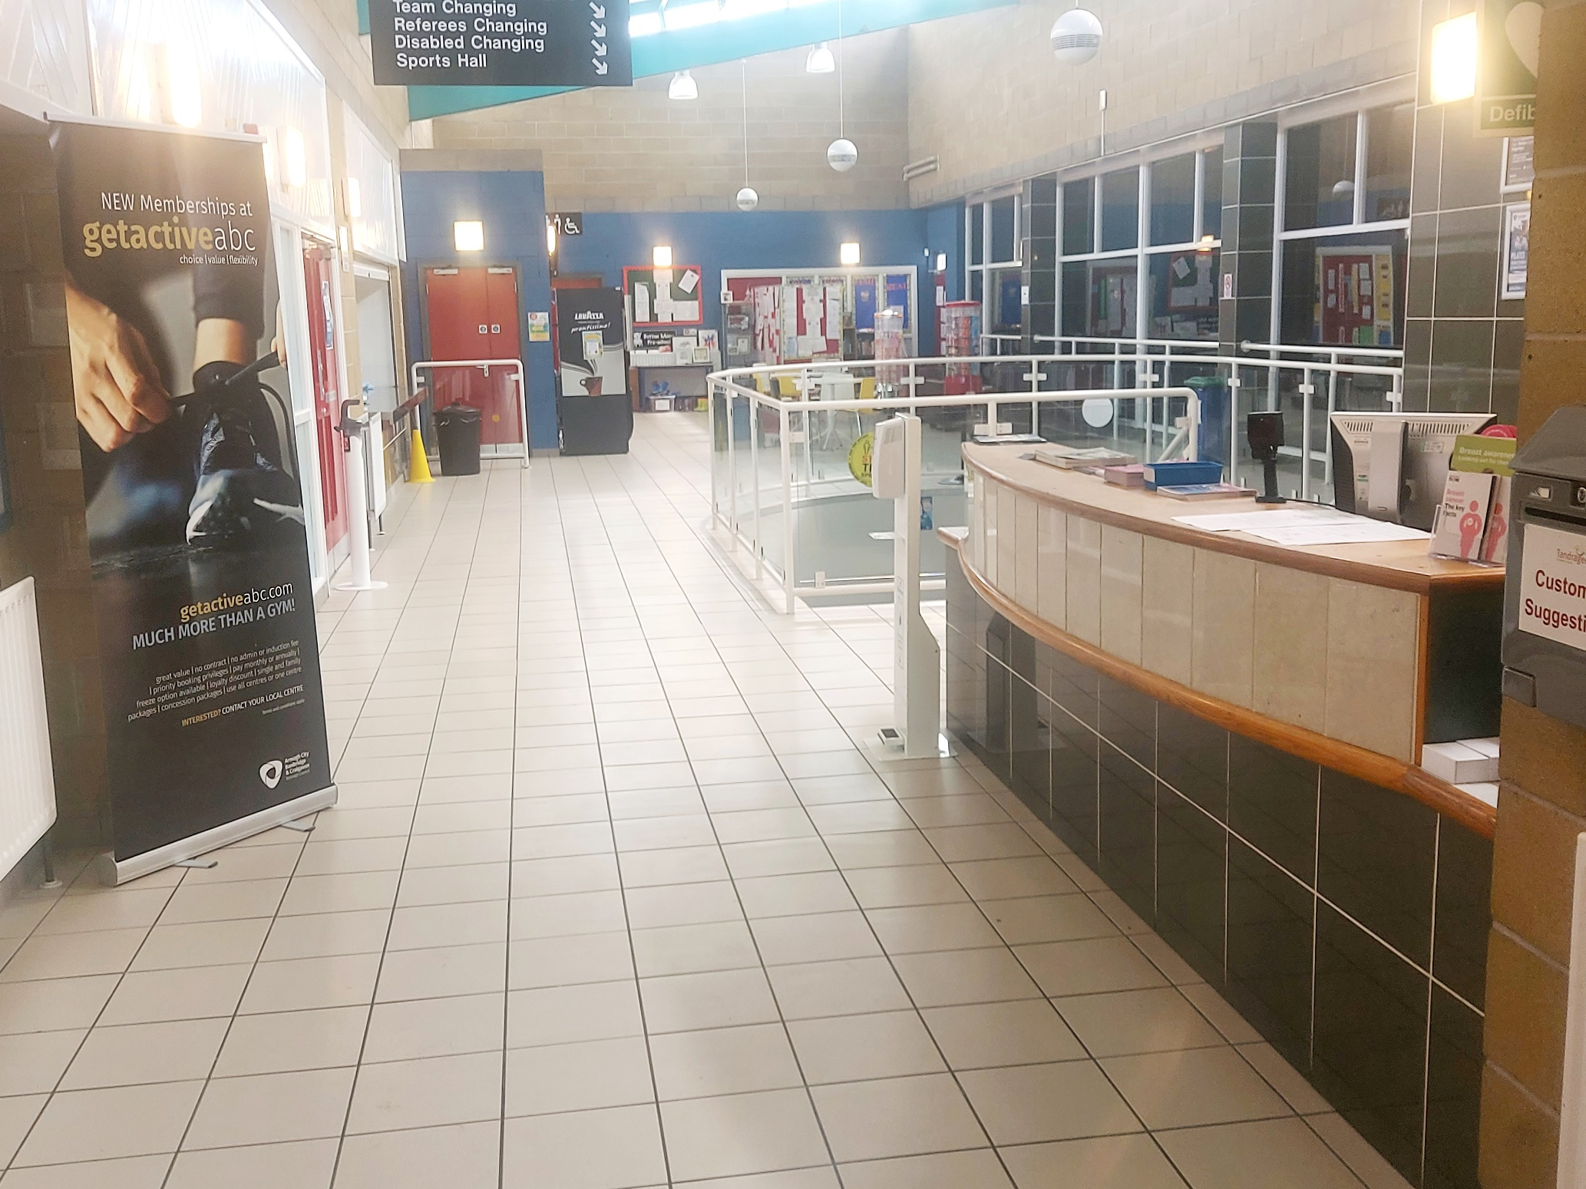

When you come in, speak to a member of staff and they will advise you where you should go.

Ground Floor Toilets

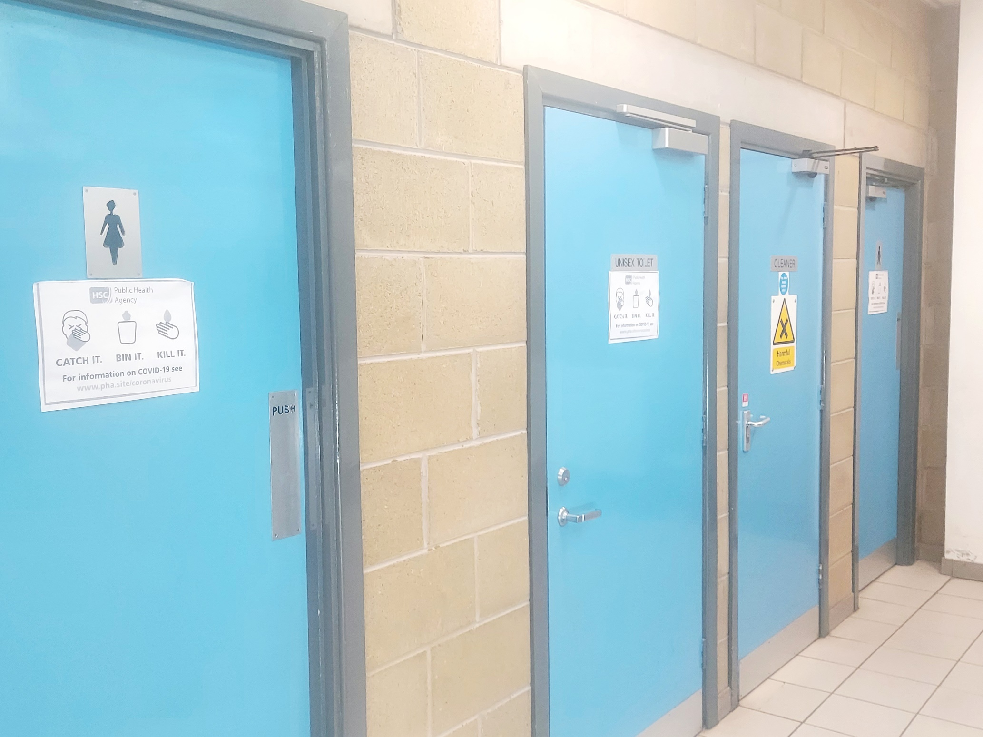

Toilets are located on both First & Ground floors of the centre. We have accessible toilets and baby changing room facilities.

Noises you might find in Toilet Area:
• Fire alarm testing, music and public announcements through speakers

Smells you might notice in Toilet Area:
• Cleaning Products after Toilets have been cleaned

Cafe Area

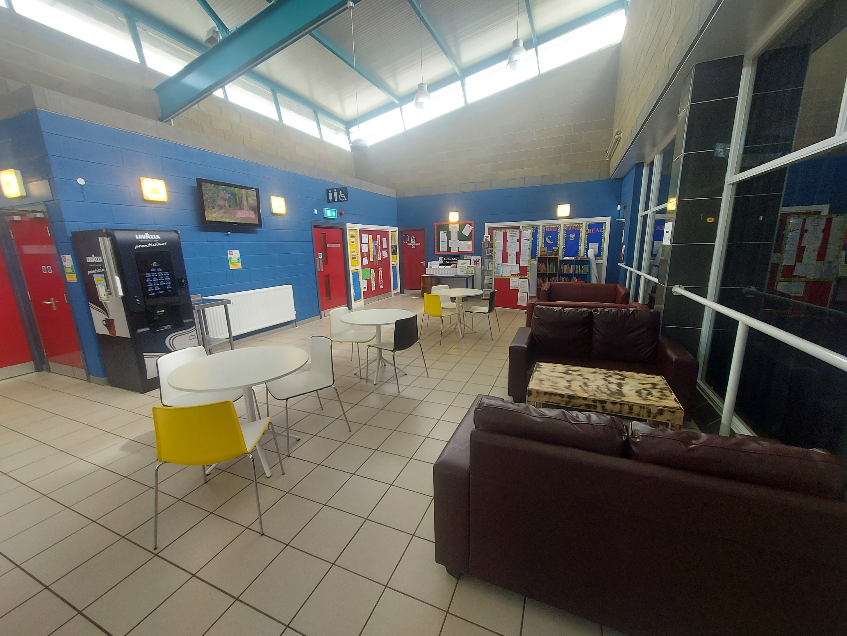

Noises you might find in Cafe Area:
• Children yelling, shouting and laughing.
• People talking loudly or shouting
• Fire alarm testing, music and public announcements through speakers
• Noise from the T.V. monitor and Coffee Machine
• Chairs banging against tables in seating area

Smells you might notice in Cafe Area:
• Cleaning Products after Breakout Area has been cleaned
• Food
Coffee and Tea

MAIN HALL

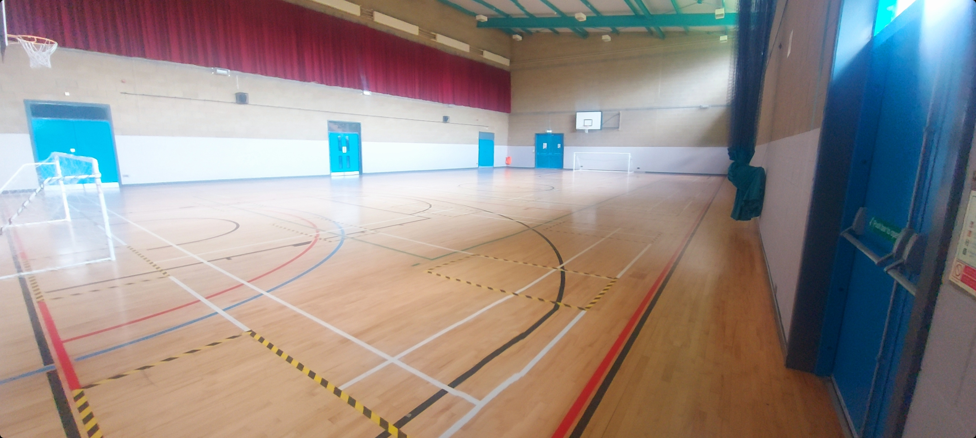

Noises you might find in the Main Hall:
• Loud music playing when exercise classes are in progress.
• Shouting and yelling whilst some sports are being played
• Children yelling, shouting and laughing whilst Birthday party is in progress.
• Fire alarm testing, music and public announcements through speakers
• Motor noise coming from the blowers while Birthday Party is in progress

FITNESS SUITE - STRENGTH & CONDITIONING AREA

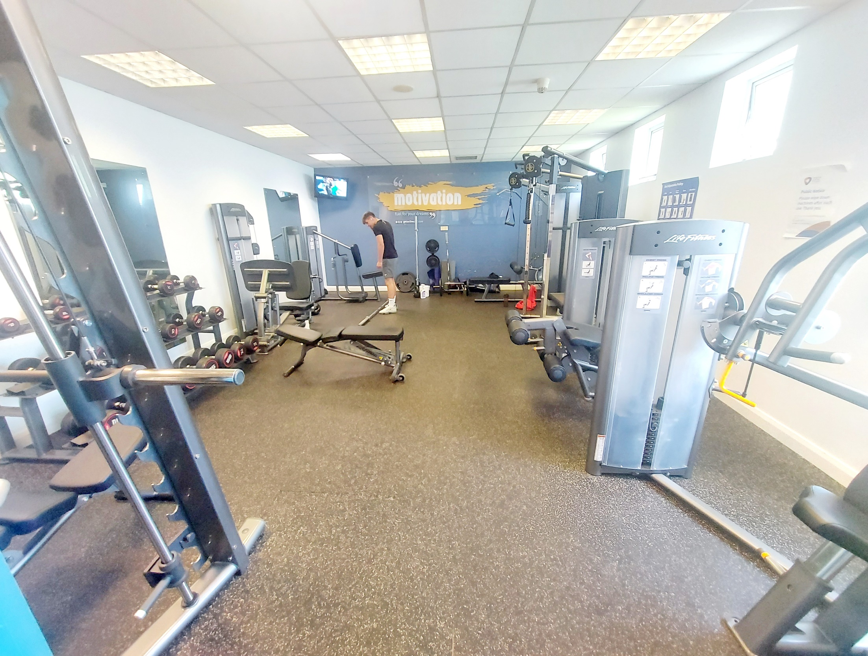

FITNESS SUITE - CARDIO AREA

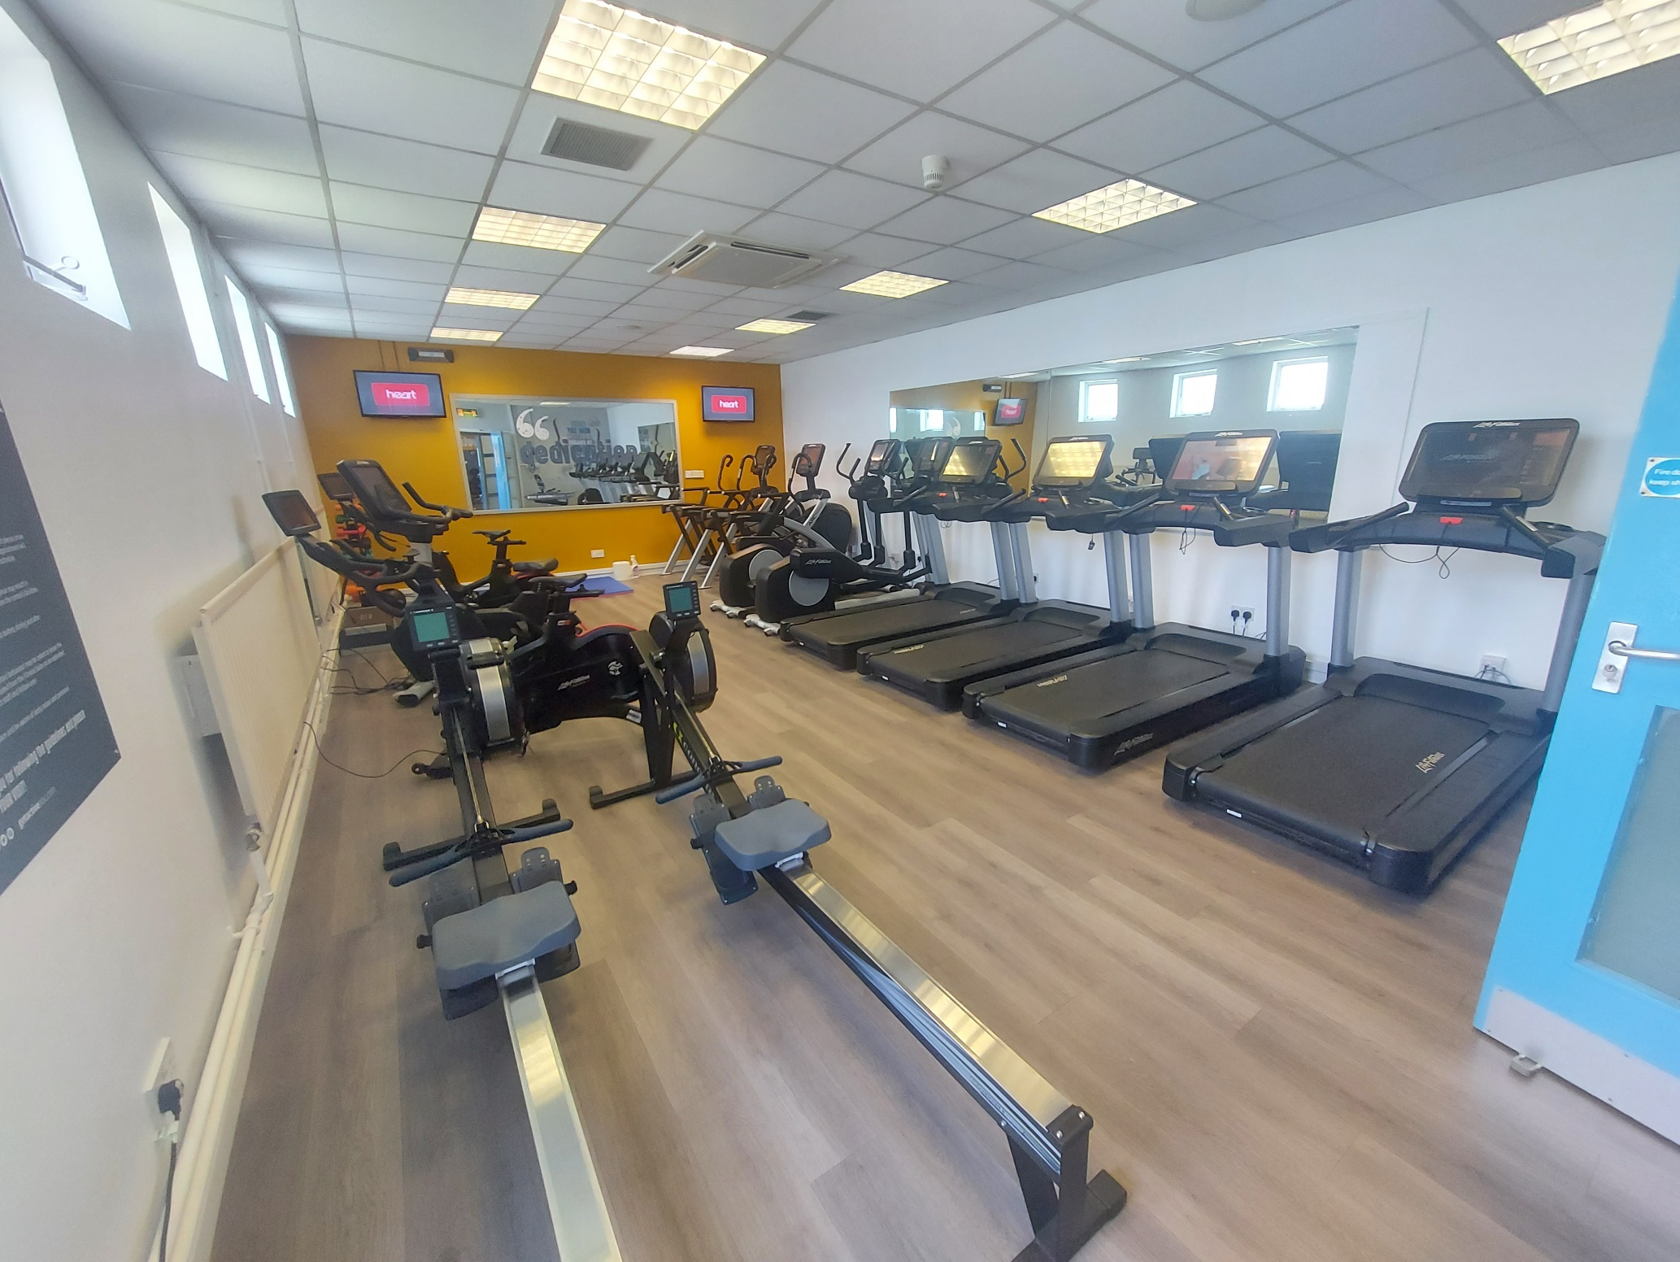

Noises you might find in the Fitness Suite:
• Loud music playing
• Heavy weight equipment clanging and banging together
• Customers talking loudly to each other
• The whirr of machines being used by customers
• Fire alarm testing and public announcements through speakers
• Two way radio activity and staff instruction

Smells you might notice in Fitness Suite:
• Cleaning Products after room has been cleaned

Changing Area

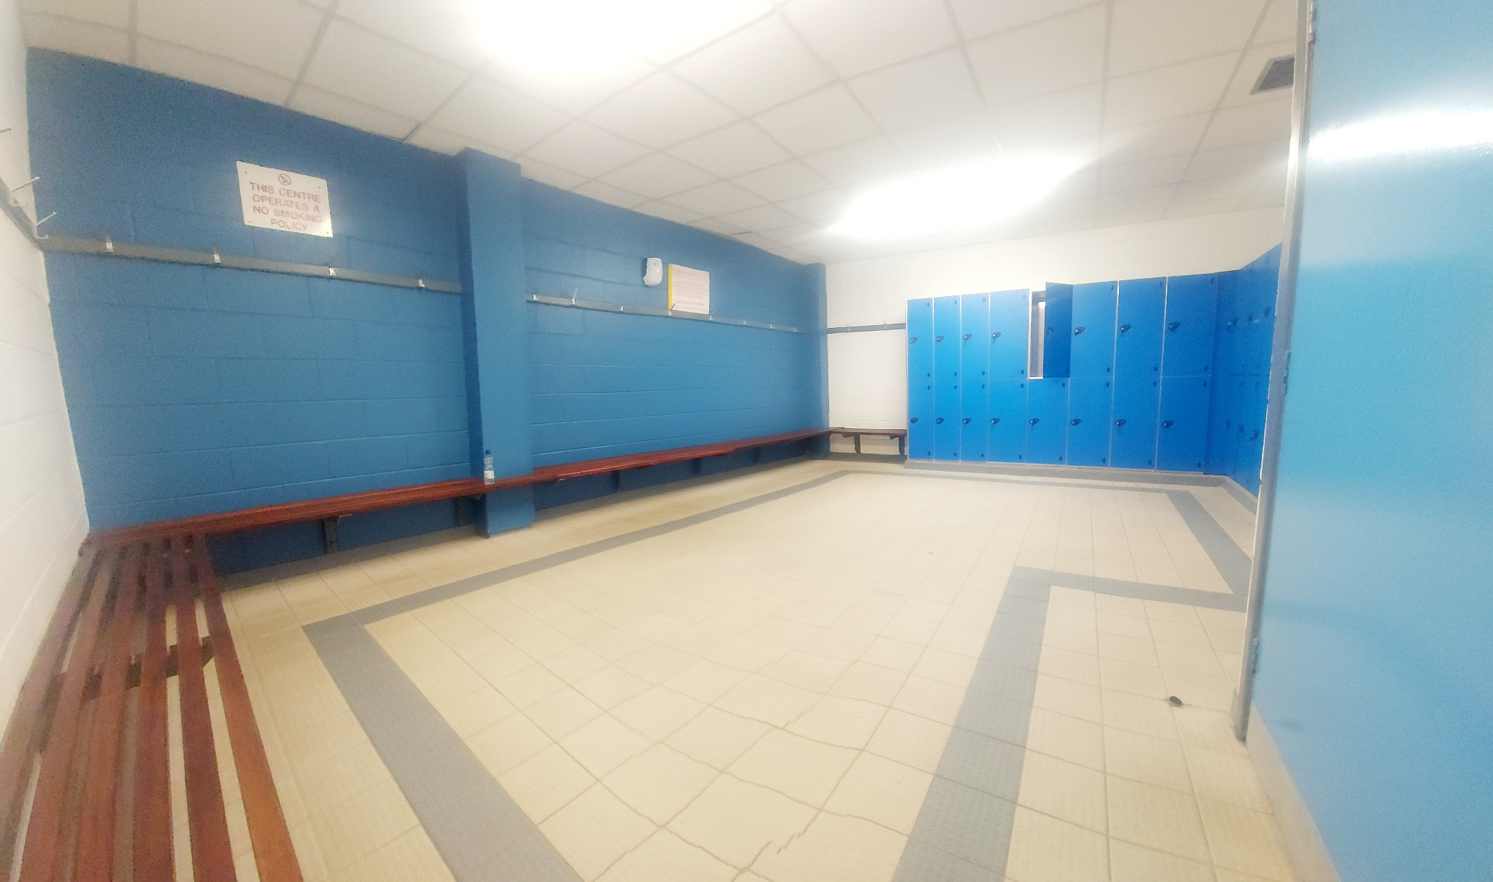

Noises you might find in Changing Area:
• Fire alarm testing, music and public announcements through speakers
• Loud music playing
• People talking loudly or shouting at times

Smells you might notice in Changing Area
• Cleaning Products after area has been cleaned
• Shower gel /Shampoo

Studio 1

This is a multipurpose room. It can be used for birthday parties, meetings and exercise classes.

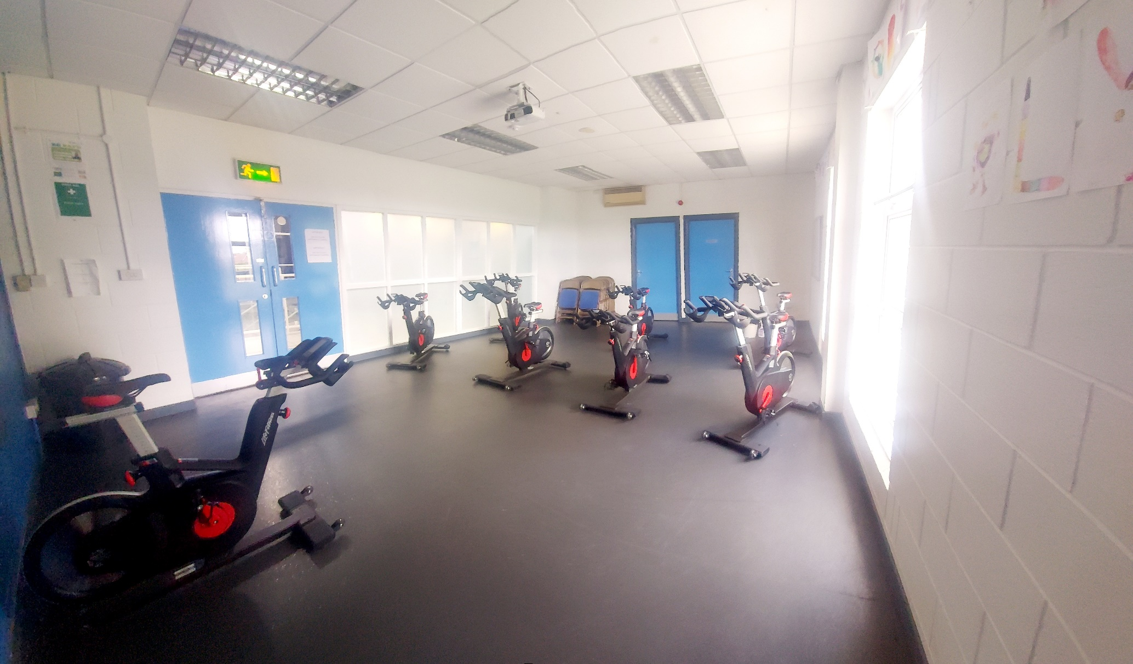

Noises you might find in Studio 1:
- Loud music playing when exercise classes or parties are in progress.
- Fitness equipment clanging and possibly banging together
- Children yelling, shouting and laughing if attending a Party.
- Fire alarm testing and public announcements through speakers
- People talking loudly or shouting at times
- Chairs banging off tables during a party
• Fire alarm testing, music and public announcements through speakers
- T.V.

Smells you might notice in Studio 1:
- Cleaning Products after Studio 3 has been cleaned
- Food
- Tea/Coffee

OUT DOOR 3G SYNTHETIC PITCH

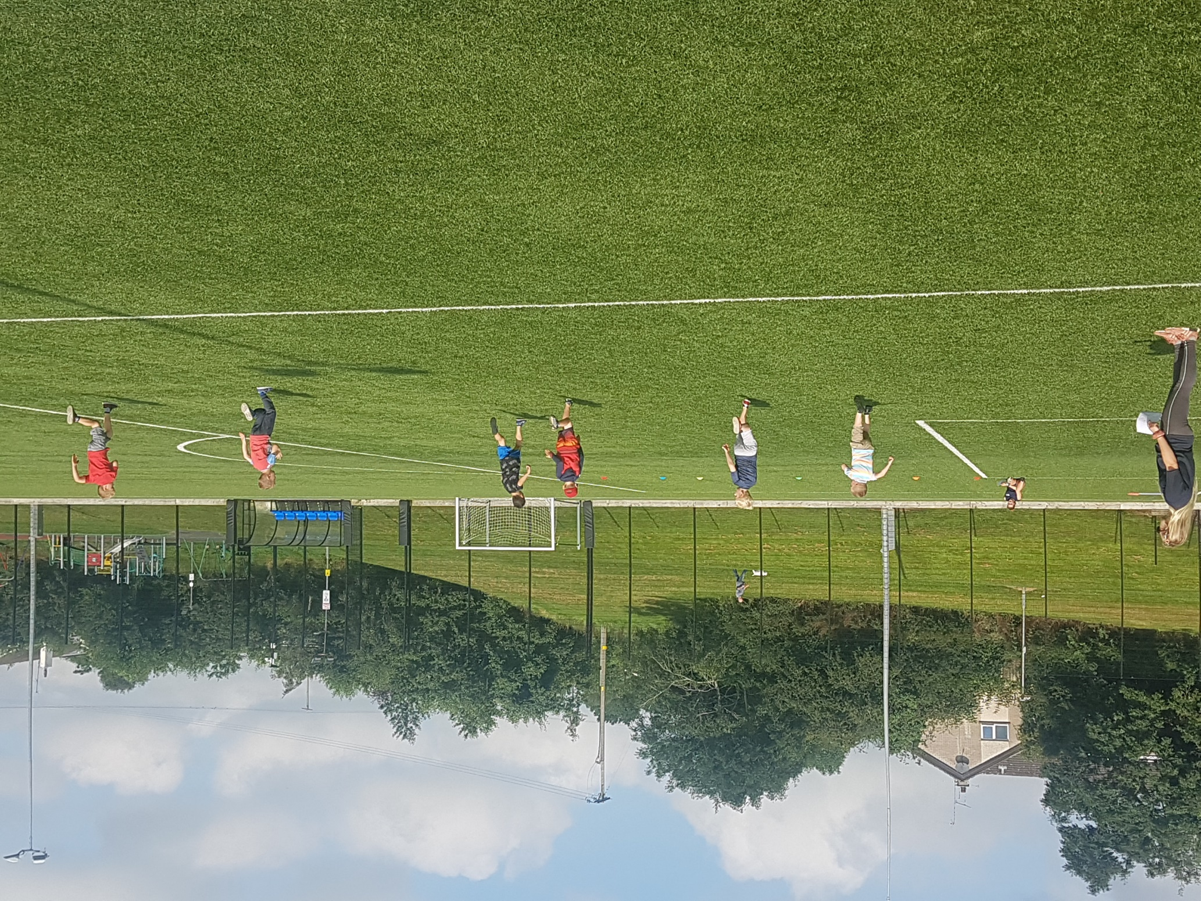

Noises you might find in the 3G Pitch:
• Loud music playing when exercise classes are in progress.
• Shouting and yelling whilst some sports are being played
• People yelling & shouting whilst matches in progress

For assistance, please speak to a member of staff, they can be identified by their uniform.

