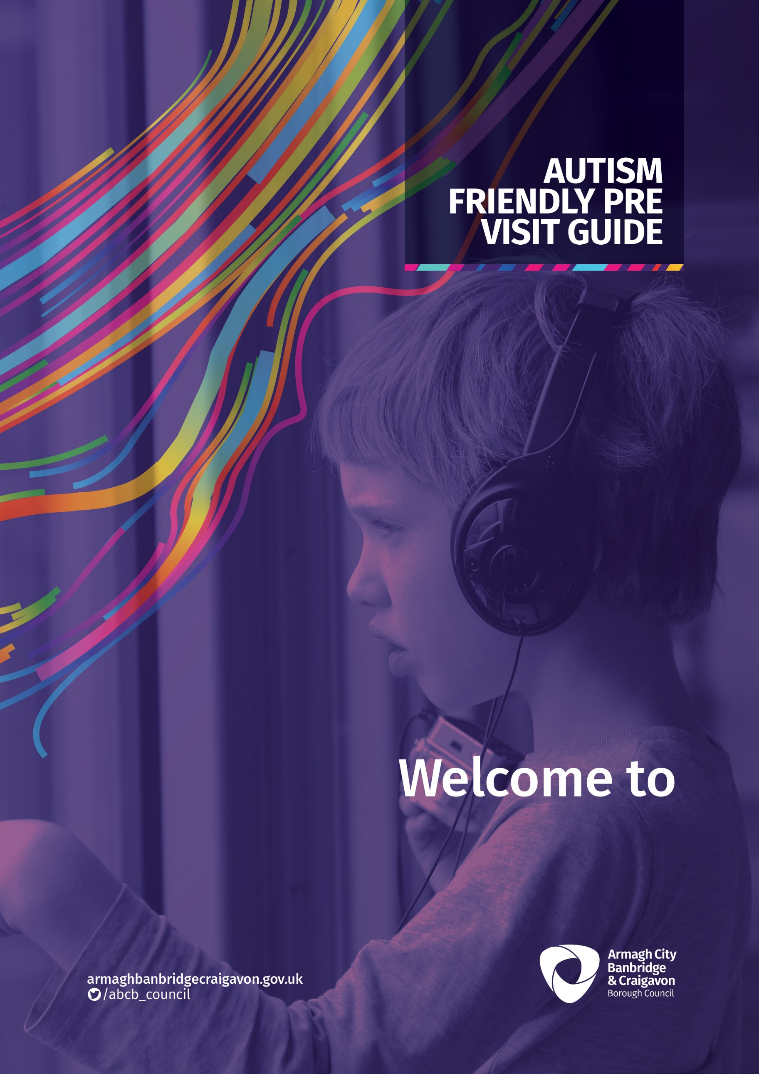
Richhill Recreation Centre
Everyone feels different when trying something new.
There are new sounds, smells and you may not know what to expect.

Location of Venue:

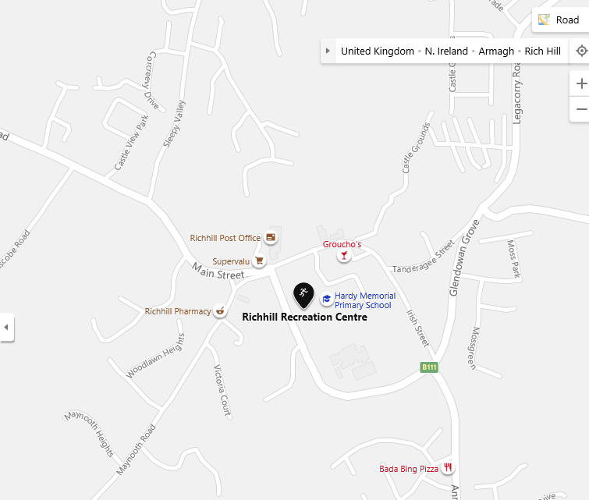

Richhill Recreation Centre can be accessed by bus / car / walking. Traffic will leave the A3 from Armagh or Portadown into Richhill Village.
Car Parking is available on site at the centre.

Welcome to Richhill Recreation Centre:

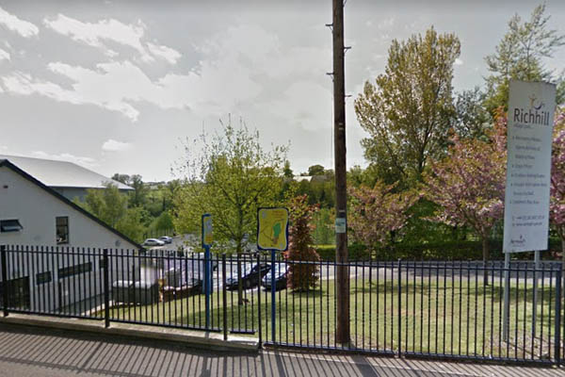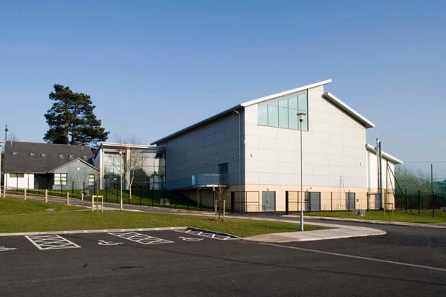

Reception area when entering the building.

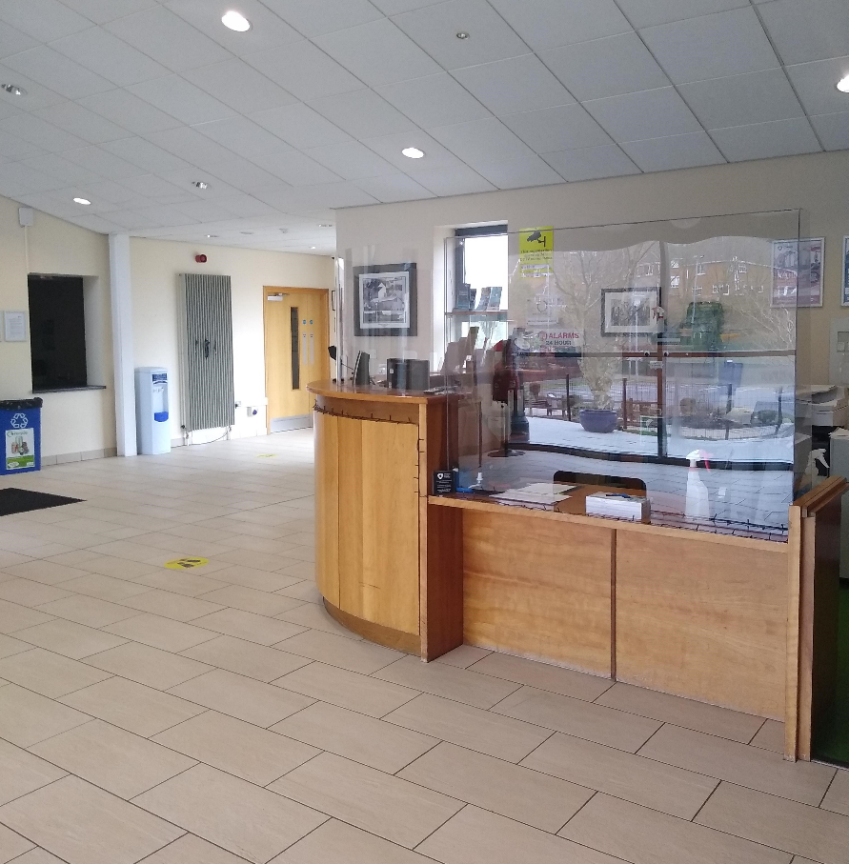

When you come in, speak to a member of staff and they will advise you where you should go.
This is the main corridor in the building for access to toilets, changing and the larger committee room.

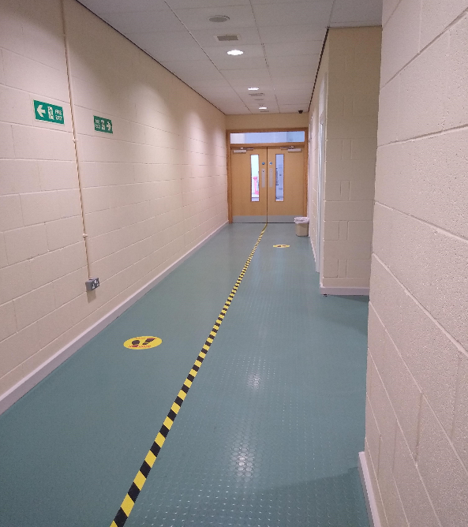
The toilets are on the main corridor just past reception.
We have an accessible toilet and changing room.

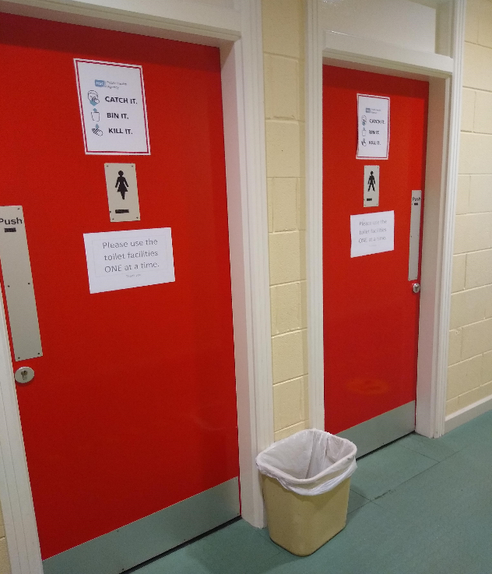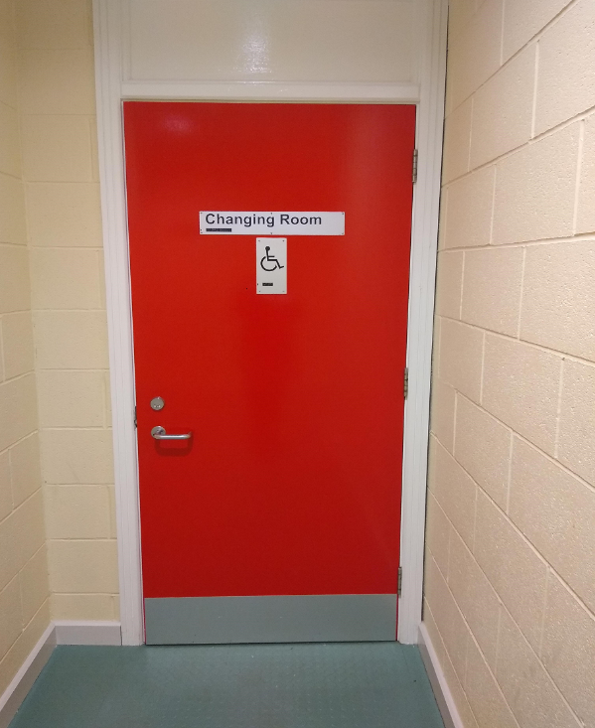

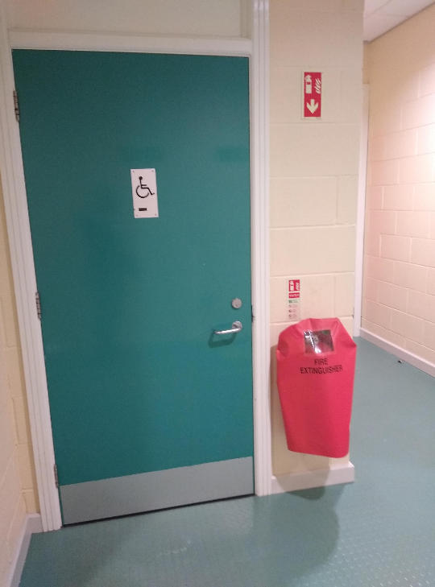

Main Hall:

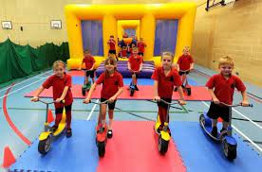

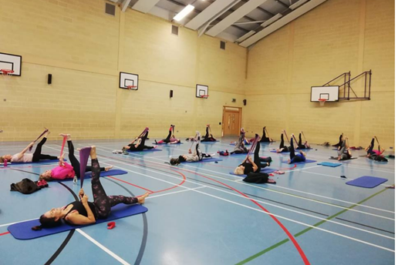

Noises you might find in the Main Hall:

Loud music playing when exercise classes are in progress.
Shouting and yelling whilst some sports are being played
Children yelling, shouting and laughing whilst Birthday party is in progress.
Fire alarm testing, music and public announcements through speakers
Motor noise coming from the blowers while Birthday Party is in progress

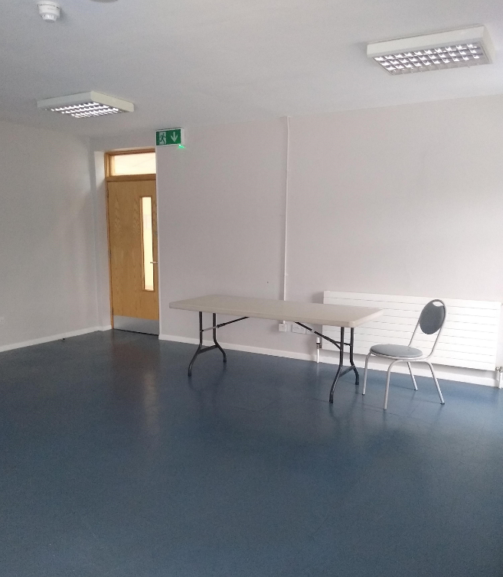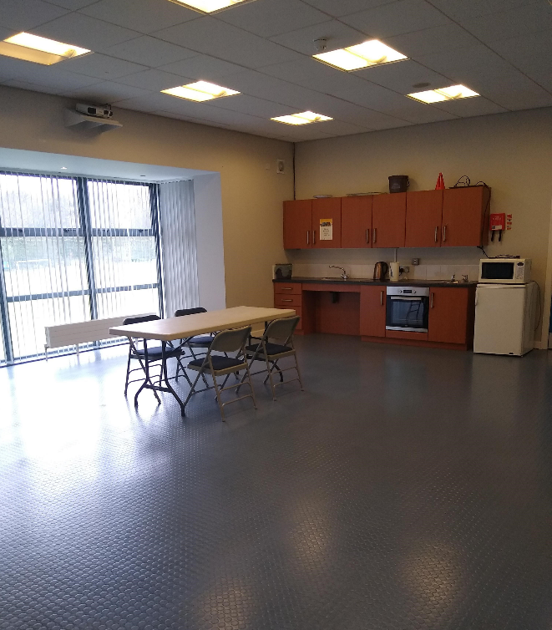

These are the committee rooms in the centre.
They are can be used for birthday parties, meetings, exercise classes.

Noises you might find in this room:

Loud music playing when exercise classes are in progress,
Children yelling or shouting and laughing whilst party is in progress.
Fire alarm testing, music and public announcements through speakers
Fitness equipment clanging and possibly banging together
People talking loudly or shouting at times
2 way radio activity and staff instruction
Noise from T.V.

Smells you might notice in this room:

Food
Coffee/Tea
Cleaning Products after room has been cleaned

Quieter times within the centre are usually from 4pm to 6pm if you would like to visit to ask questions or have a look around.

Richhill recreation centre once you enter the building, is on one level.
There are no stairs or lifts.

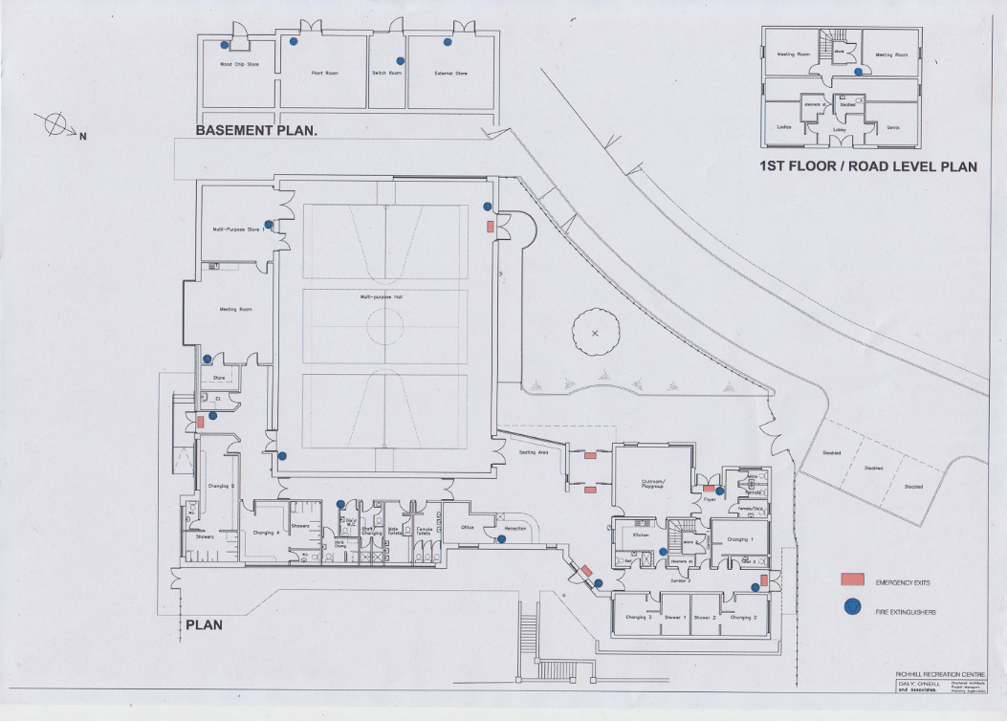

For assistance, please speak to a member of staff, they can be identified by their uniform.

